



KNOWLEDGE INSTITUTE OF TECHNOLOGY

(An Autonomous Institution)
Department of Mechanical Engineering

TEAM NAME: SPARKERS

DESIGN REPORT






CHAPTER |  | PAGE
NO | TABLE OF CONTENTS  TITLE | NO

1 | ABSTRACT | 3
2 | INTRODUCTION | 3
3 | MATERIAL SELECTION | 4
4 | FINITE ELEMENT AND ANALYSIS | 5
5 | STEERING | 7
6 | BRAKING | 9
7 | ENGINE AND TRANSMISSION | 15
8 | CONCLUSION | 17

Abstract

The primary objective of the team is to manufacture safe and practically functional go kart achieving high values of max speed without compromising the fuel efficiency with minimum amount of emissions and this all to be done within the set of rules explained in the AIMS rulebook.

Teams aim is to design the go kart managing the weight distribution over the chassis and diver comfort. Analysis of the all the significant subsystems are done for enhancing the performance and efficiency of the kart under various unfavorable conditions that might arise in the racing conditions.

1.Introduction: -

We approached our design by considering all possible alternatives for a system & modelling them in CAD software like solid works, ansys etc. and subjected to analysis using ANSYS FEA software. Based on analyses result, the model was modified and retested and the final design was frozen.

The design process of the vehicle is iterative and is based on various engineering and reverse engineering processes depending upon the availability, cost and other such factors. Safety, Serviceability, Strength, ruggedness, Standardization, Cost, Driving feel and ergonomics, Aesthetics. Driver's comfort, safety, cost and efficiency are the main things we've focused on while making this GO Kart.

The design objectives set out to be achieved were three simple goals applied to every component of the car: durable, light-weight, and high performance, to optimize the design by avoiding over designing, which would also help in reducing the cost. With this we had a view of our kart. This started our goal, and we set up some parameters for our work, and distributed ourselves in groups.
2.Design methodology: -
Ergonomics: -

Ergonomics is the process of designing or arranging workplaces, products and systems so that they fit the people who use them. Ergonomic considerations:

a. We want our kart to be comfortable for the driver even after long use.

b. We prioritized the safety of the driver in the kart

c. Making the handling of machine levers and controls easy.

d. We want to optimize the performance of the kart without affecting driver comfort.
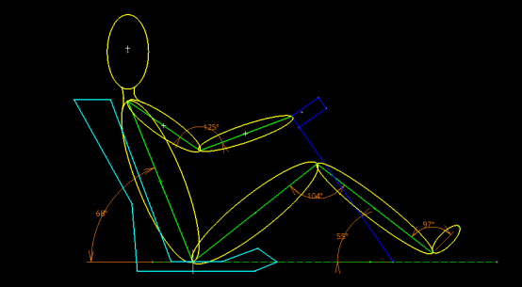

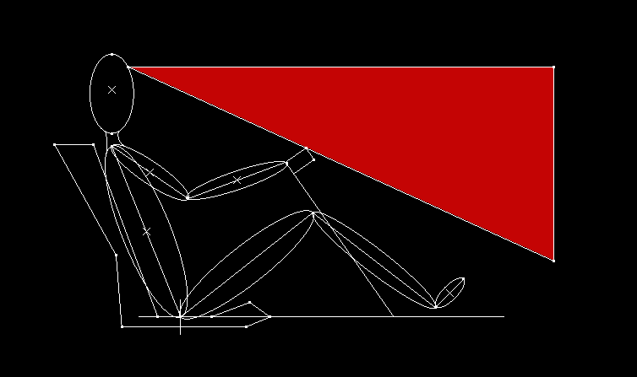
Driver sitting layout
Drivers vision cone

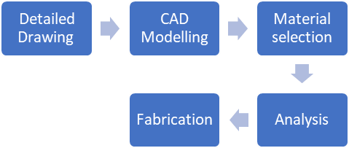
Step of formation of chassis:

3.Floor planning: -

In the flour planning, for high performance of our drivers, for its comfort make every dimension by considering both of our drivers for its comfort, also every member is place according to it, by consideration of all mounting.

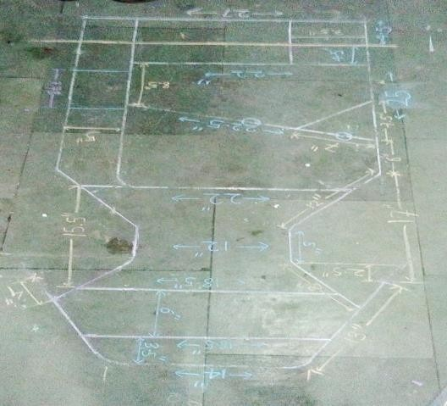

4.Frame design: -

Design of any component consists of three major principal which are: -

Safety

Optimization

Comfort


For the design of frame, we follow certain steps by considering our priorities and principle, the main objective for consideration is the driver safety. In this step we make various plans for perfecting and optimization of the mountings. all this design is made as per AIMS rulebook.

After various design flour plan, we make CAD models, give them material and we did ANSYS and get best result after considering all the principal and parameter, the design is fixed. This design gives us a satisfactory result for our kart.

5.Design: -

The frame is designed to meet the technical requirement of the competition. According to the above specific dimension and competition rules, we finalized our frame design whose view is given below.
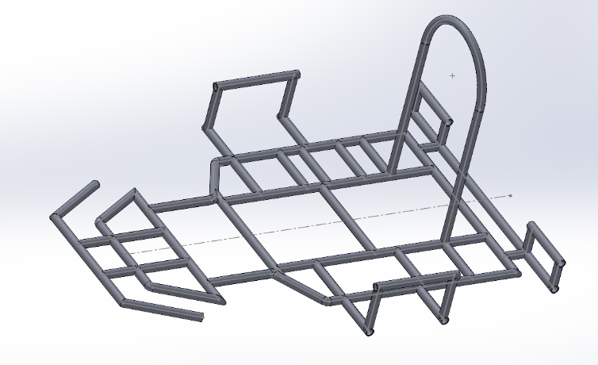

3-D views of the kart
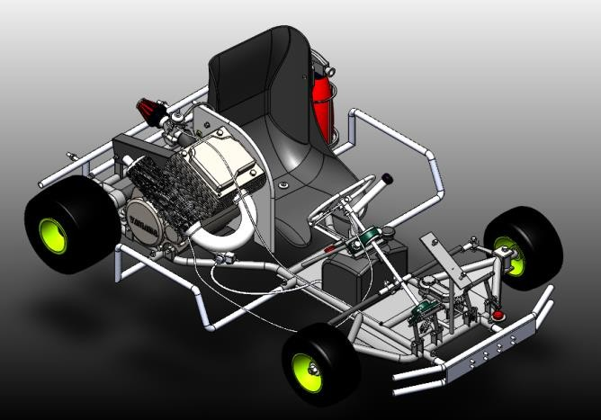

Isometric view no. 1
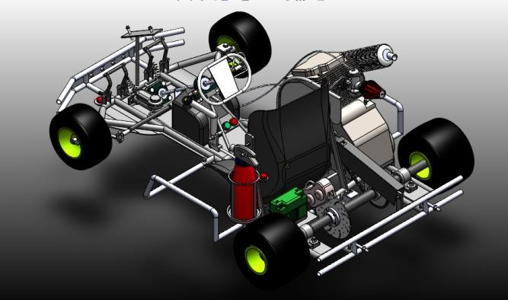

Isometric view no. 2

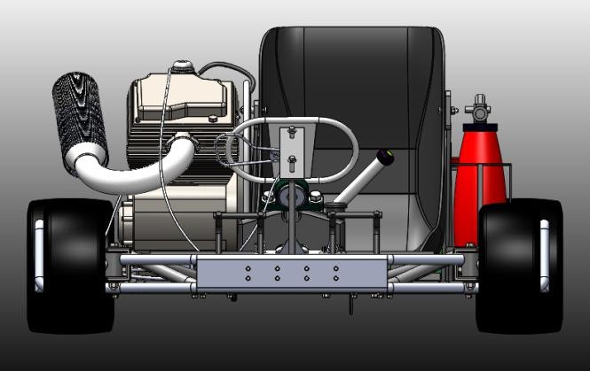

Front View

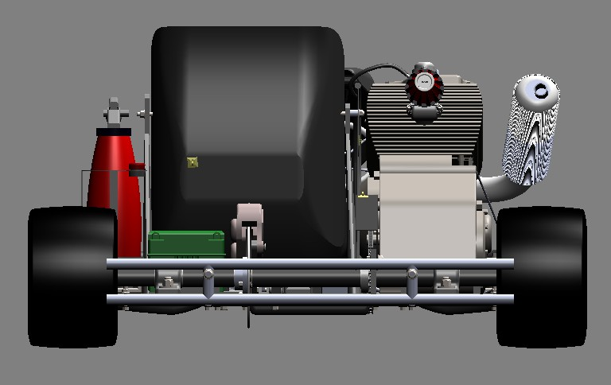

Rear view

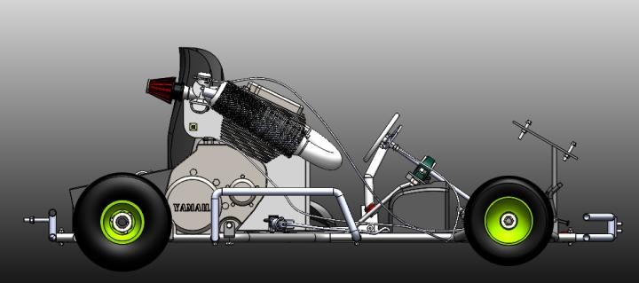
Side view

6.Material selection: -

The proper material selection has the very important role in the weight, durability and safety of the kart. So, it is the basic requirement for any design. To find the right material that fits the requirements of the design to be lightweight but have more strength at the same time is a very important part of the design.

First, we did market research for available materials, and we found the commonly used materials for automobile chassis that are AISI 1018, AISI 1026, and AISI 4130. Among these 3 we found the overall properties of the AISI 4130 are better than the other two. So, we have chosen the AISI 4130 for the chassis material.

Properties | AISI 1018 | AISI 1026 | AISI 4130
Density (Gm./Cm²) | 7.8 | 7.8 | 7.8
Elasticity (Gpa) | 210 | 210 | 210
Elongation  % | 18-  29 | 17-  27 | 18-  26
Thermal Expansion (µm/Mk) | 11.9 | 11.9 | 11.8
Uts (Mpa) | 430-  470 | 470-  530 | 560-  1040
Yield Strength  (Mpa) | 240-  400 | 415-  450 | 435-  980

Functions of the chassis: -
a. To carry loads of the driver and mountings.
b. To support the load of the engine, transmission etc.
c. To withstand the forces caused due to the sudden braking or acceleration. d. To withstand centrifugal force while cornering.
e. We have designed a chassis which will provide an appropriate space for each component of the kart with driver ergonomics.
The basic dimensions of structural member of the chassis are shown below Now.

Outer diameter | 25.4mm
Inner diameter | 21.25mm

Finite element analysis: -

In FEA we tried to optimize the chassis frame by making changes after analyzing the results. We wanted the chassis not to be overdesigned or under designed.

So, we used ANSYS to analyze the chassis and applied 4G forces for the front and rear impact and 2G forces for side impact.

We wanted to achieve the factor of safety between 2 to 4 for the chassis for front, side and rear impact and more than 1 for torsional impact.

Impact | Force
Front | 3335N
Side | 3335N
Rear | 3335N
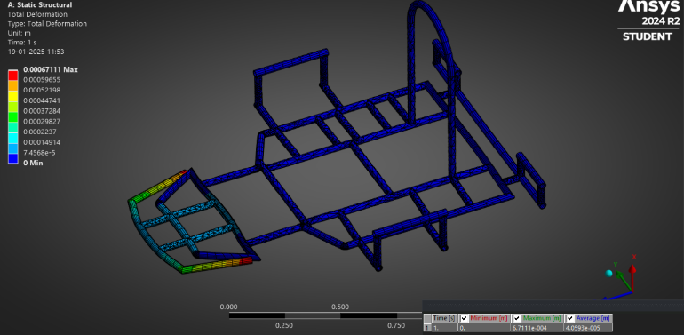

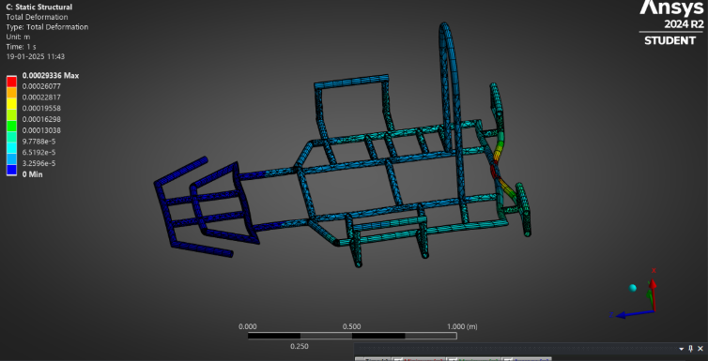
Front impact

Rear impact
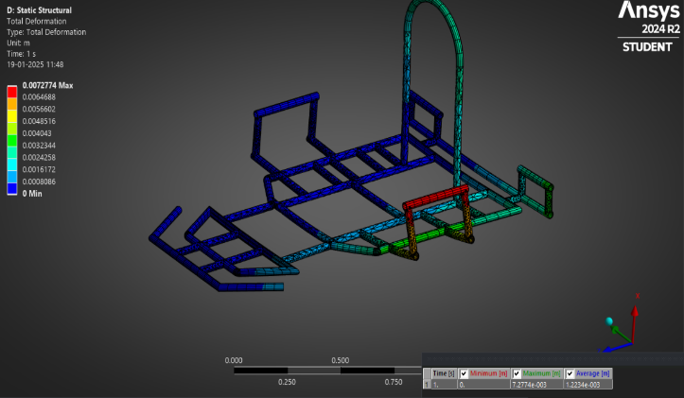
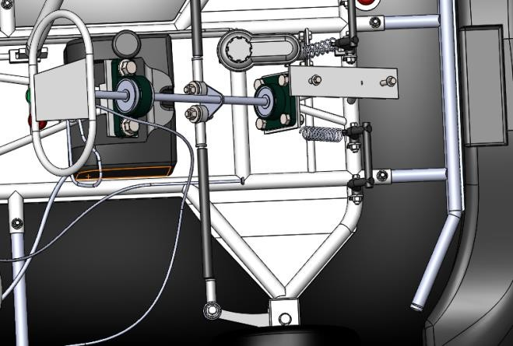

Side impact

Subsystems

7.Steering: -

To increase effective overall performance of the kart steering geometry is very important. We wanted to achieve 1:1 steering ratio and for this we designed the length of the pitman arm equal to length of steering arm.

As the go karts do not have differential it is required that we design a steering system which provides efficient cornering.

The jacking effect is used in go karts for better cornering. In jacking effect, the outer rear wheel lifts and faster cornering speeds can be achieved. To implement jacking, we adopted KPI (King Pin Inclination) 0 degree towards center of the kart for effective cornering. Another important angle is the castor angle which provides straight line stability to the kart and helps to self centre the steering we decided to adopt 10-degree positive castor. To decide the values of castor and KPI we referred to many research papers based on go karts. We decided not to adopt any camber because it will lead to uneven wear of tires.

Cad model of steering system

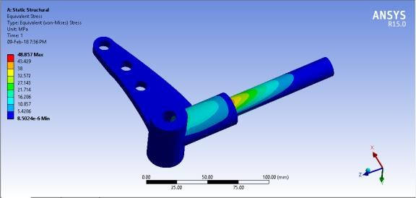
Analysis of stub axel is done by applying 410N force in upward direction and the FOS is calculated as 5.
Analysis of knuckles.
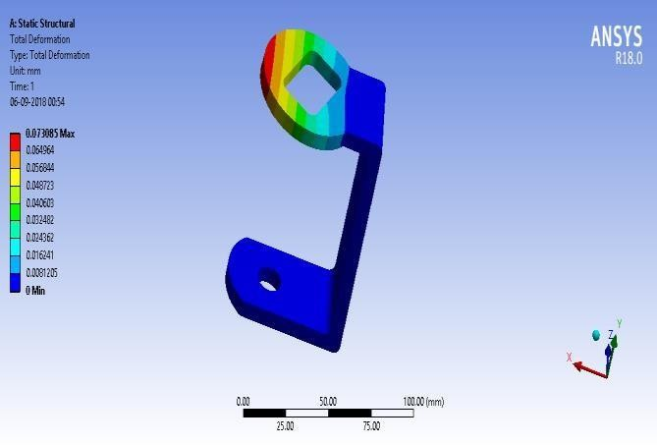

Analysis of C-Clamp

The CAE of the spindle and c bracket at static conditions was done on ansys software. The material used for steering system is mild steel.

The FOS and deformation was calculated: -

 | Spindle | C Clamp
FOS | 10.013 | 7.55

Result table: -

Parameters | Value
Steering system | Ackerman
Track width | 1016mm
Wheelbase | 1041mm
Inner angle | 34
Outer angle | 22 .57
Ackerman angle | 26
Turning Radius | 2.7 mm
Steering Ratio | 1.25: 1

8.Braking System: -

Objective: -

The main purpose of the braking system is to stop the vehicle in motion within the shortest possible distance. It exists to convert the kinetic energy of vehicle in motion into thermal energy. They are required to stop the vehicle, and this is done by converting the kinetic energy into heat energy which is dissipated into the atmosphere.
- DRUMBRAKES
- DISC BRAKE
- HYDRAULICBRAKES

We have decided to use disc brake for our vehicle because of the following advantages:

Disc Brake: -

1)They are more linear in their operation and less prone to locking up.


2)Open design of disk brake mechanism allows more efficient cooling than enclosed drum brake.

3)They are more resistant to water because the brake rotor slings it away and the brake pads serve assuage.

Material selection: -
At the time of material selection, we had considered 2 materials, grey cast iron and SS410. We selected SS410 for the disc material due to the following properties.
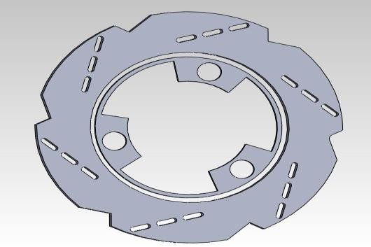

Disc in Cad Model

PROPERTIES OF MATERIAL: -

Parameters | GRAY  CAST IRON | SS410
Thermal  conductivity(K/mk) | 58 | 27
Density (kg/m³) | 7800 | 7850
Specific  heat(KJ/kgk) | 460 | 500.3
Coefficient of  Friction | 0.4 | 0.5
Compressive  strength (Mpa) | 1293 | 550
Ultimate  strength (Mpa) | 320 | 827
Yield  strength (Mpa) | 210 | 620
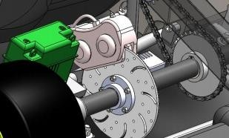

Cad Model of brake

Master Cylinder: -
The function of master cylinder is to translate the force from the brake pedal assembly into hydraulic pressure.
We considered two type of brake fluids as follows:
DOT3.
DOT4.
We have used DOT4 fluid because it has a higher boiling point than DOT3, making the fluid less likely to boil. Also, the viscosity of DOT4 is more than DOT3 and it maintains its fluidity at a higher temperature. Also, the brakes shall be more effective when the system gets hot during a long drive.

Parameters | Respected values
Braking torque | 855.42 N m
Clamping force | 15946.254N
Disc diameter | 200mm
Disc thickness | 3mm
Brake fluid  used | Dot 4
Load distribution | 35% at front
 | 65% at rear

Speed (km/hr) | Stoping Distance  (m) | Stoping Time  (sec)
30 | 5.1 | 1.20
50 | 13.8 | 2.0
70 | 27.71 | 2.8

Caliper: -
The main function of Brake Caliper is it holds and guides the brake pads. It also converts the hydraulic pressure in the brake system into a mechanical force which presses the brake pads against the brake disc.

Wheels: -
Wheels allow the vehicle to move smoothly on the surface. We’re using Go kart tires using the dimension 10*4.7*5 inches for the front wheel and 11*7.1*5 inches for the rear wheel.

9.Transmission: -
The Honda unicorn 149.5cc engine contains a wet clutch system with internal manual gearbox. The output of the gearbox is coupled with axle with the help of chain drive having 16teeth on the gearbox output while 32 teeth on the axle. The shaft diameter is 30mm. The kart is a rear drive kart having tires of 11inches diameter at rear and 10 inches at the front.
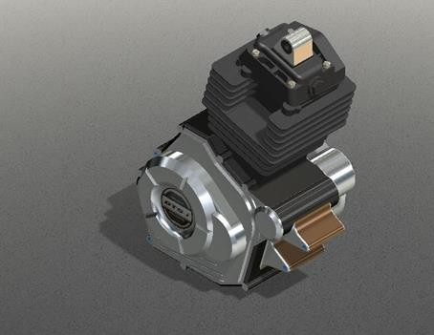
Kart Engine

As per the norms provided by AIRC, our vehicle is rear wheel drive. We use the manual gear box and chain drive to avoid complexity of transmission. It plays a key role in maintaining the most possible rpm, which is also making sure that the engine is not allowed to overheat and ultimately explode. The range of the engine under max torque and power output.

Engine | Honda Unicorn 149.5cc
Max. Power | 14.5bhp @ 8000 rpm
Maximum torque | 14.6 Nm @ 6000 rpm

10.Calculation of shaft Diameter: -

In shaft designing calculation, shaft diameter is important. We are taking solid shaft for our go-kart. Transmission shafts are subjected to combined bending and torsional moments.

Shaft design on strength basis:

1)Maximum principal stress theory

2)Maximum shear stress theory


We have used maximum shear stress theory for shaft design which is applicable to ductile materials. Since the shafts are made of ductile materials, the maximum principal stress theory is not applicable to shaft design as it gives good prediction for brittle materials.

11.Exhaust Design: -

Design of exhaust consists of three major parameters which are: -
- Back pressure
- Heat transfer
- Vibrations
These 3 parameters are taken into consideration for well design exhaust system which collect exhaust gas from engine cylinder & discharge then as quickly and silently for good engine performance to reduce the vibrations and maintain the engine temperature.
After studying various designs of exhaust, we finalize this design because of
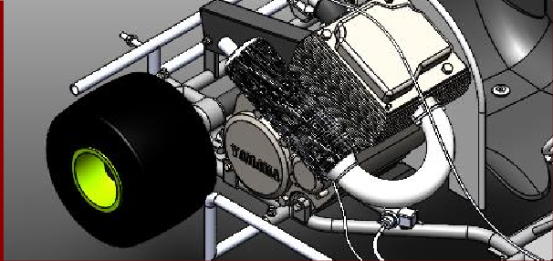
sharp bends b) length of exhaust c) small diameter. Back pressure gets increases that’s why we take some straight pipe at the beginning & circular bend (180º) & length of pipe.
Exhaust manifold

12.Safety equipment: -

- Kill switch
- Fire wall
- Bumpers
- Floor pan
- Driver kit
- Fire extinguisher

13.Fabricated and prefabricated parts: -

Fabricated parts list
1.Chassis.
2.Shaft.
3.Steering system.
4.Hubs.
5.Pedals
Outsourced parts list
1.Fairings.
2.Seat
3.Disc
4.Caliper
5.Master cylinder.
6.Wheels
7.Knuckle.
8.Engine.
9.Switches And battery.
10.Cables.
11.Springs
12.Bolts and nuts.
13.Bearings
14.Fuel tank
15.Sprockets
16.Air filter
17.Fuel pipe
18.exhaust

14.Conclusion: -

We used the finite element analysis system to evaluate, create and modify the best vehicle design to achieve its set goals. The main goal was to simplify the overall design to make it lighter- weight without sacrificing performance and durability. The result is lighter, faster and more agile vehicles that improve go-kart design. The design and construction for go-kart design has become more challenging due to several constraints. Thus, this report provides a clear insight into the design and analysis of our vehicle. Thus, the making of this report has helped us in learning various software and the brief information about our kart

References: -
1)Automobile engineering Vol.1& 2
– Dr.KripalSingh.
2)A textbook of machine design
– R.S.Khurmi
J.K.Gupta.
3)Internal combustion engine- M... L.
Mathur R.P.Sharma

4)Design of Machin Element
–V.B. Bhandari
5)Fundamentals of Vehicle Dynamics
– Thomas Gillespie
6)IJAME – Design and Analysis of a Go kart –
Vol. 3 –No. 5 Sept. 16
7)Automobile engineering: -
G.B.S. NARANG

